# How To Read Meter Reports

For 280W-R

1. Connect IR tool to meter. Open YD14_SPRIE_EN_REPORT_V9.0.exe
2. Open COM port and click on F Read to read meter info. Then go to tab ReadEEp (NJ).

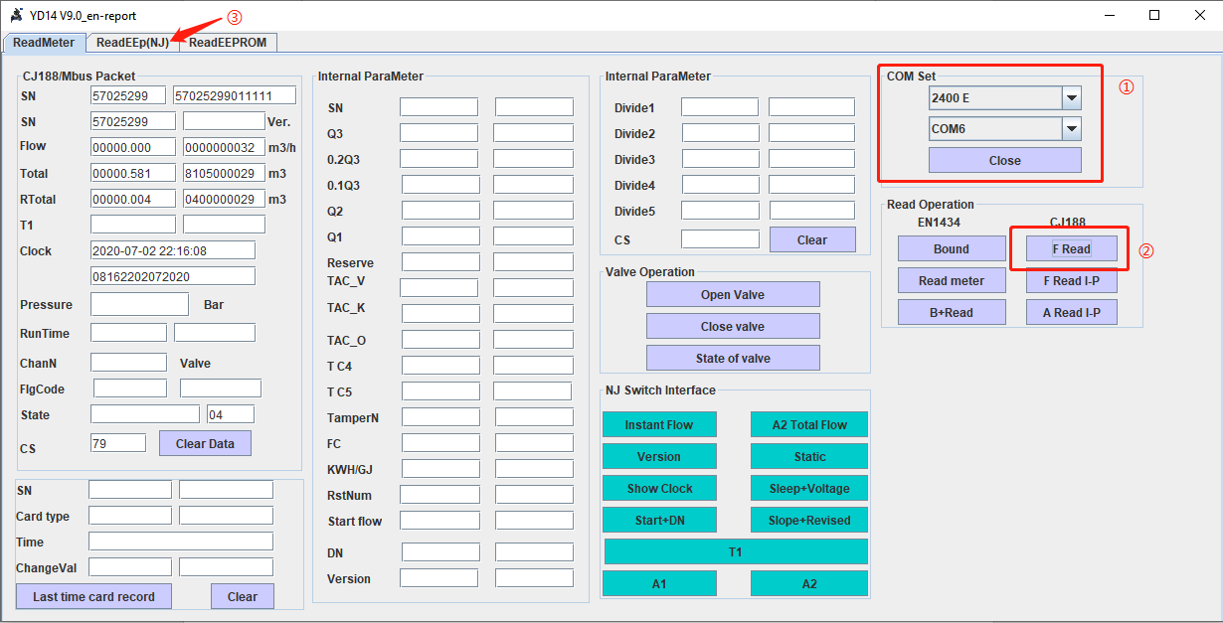

1. Enter 23 in the box on the top and click All month report to read monthly reports. Enter 24 in the box on the bottom and click All daily report to read daily reports. Click on Export to export the data to an Excel file.

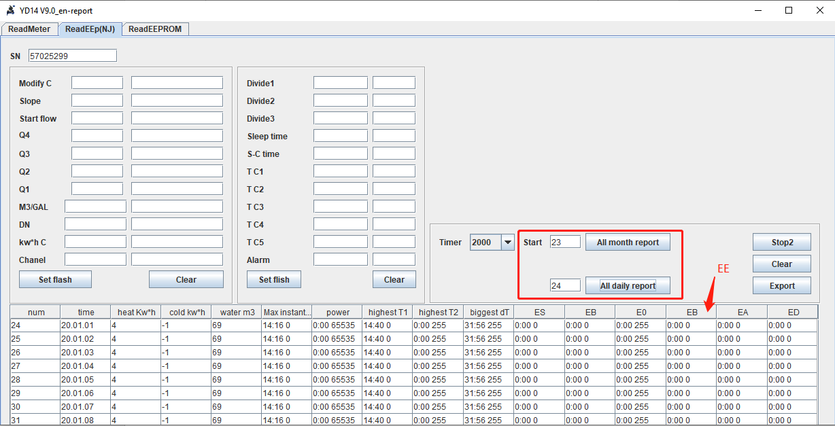

1. Notation on the report.

* Heat kW*h: N/A for water meter
* Cold kW*h: N/A for water meter
* Water m3: Flow totalizer in m3
* Max instant: Time of peak flow rate occurred and the flow rate in m3/h
* Power: N/A for water meter
* Highest T1: N/A for water meter
* Highest T2: N/A for water meter
* Biggest dT: N/A for water meter
* ES: Time and status of temp sensor short circuit alarm.
* EB: Time and status of temp sensor open circuit alarm.
* E0: Time and status of empty pipe alarm.
* EE: Time and status of PCB malfunction alarm.
* EA: Time and status of overflow alarm.
* ED: Time and status of low voltage alarm.

*Note:*

1. The second EB in the software should be EE.
2. Alarm status: 0 stands for no alarm; 255 stands for alarm.
3. To download the software: <https://files.secureserver.net/0se7wrRtYrbDeL>